|  |  |  |  |
| --- | --- | --- | --- |
| **Name:** | **Yousssef nasr sayed osman** | **ID No.:** | **21001483** |
| **Date:** |  | **Slot Number:** |  |

**Lab 1: Introduction to LTSpice**

1. **Take screen shot of the Circuit:**

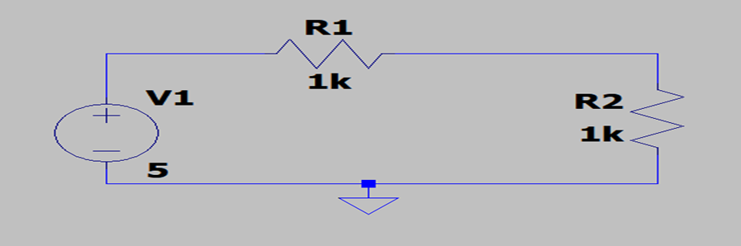

1. **Take screen shot of the DC operating point:**

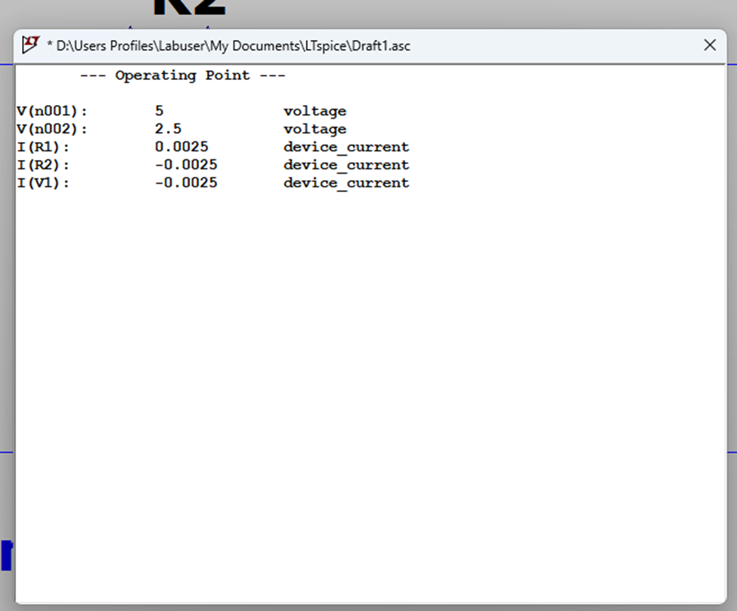

1. **Run DC sweep and take a screen shot of V1:**

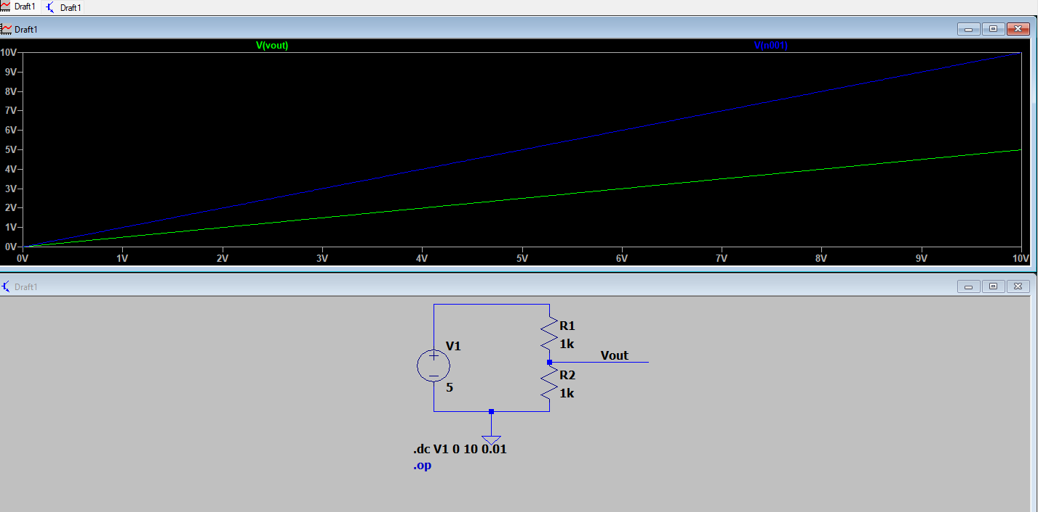

1. **Run DC sweep and take a screen shot of Vout:**

**Run DC sweep and take a screen shot of the current in the diode (ID):**

